

AP Claims Technical Spec SAMPLE

V 0.1

**Updated by:**

**Jonathan Girling**

**21st August, 2013**

**Table of Contents**

1. Introduction 3

2. Promax PX 4

3. PX Interfacing Hub 5

3.1. Validate the information from Promax PX 5

3.2. Lookup additional information for interface to ATLAS 5

3.3. Interface Logic. 6

3.3.1. Inbound 6

3.3.2. Outbound 6

4. ATLAS (APP) 7

# Introduction

This document provides the technical processes involved for Interfacing AP Claims Data out of Promax PX to SAP through the PXIPMX02 interface; This interface is also known as ‘331 Payments’ in the Promax PX Interface specification and ‘AP Claims’ when discussing with the business.

This document does not cover the specific business processes that are involved at each step. They are covered in the AP Claims Business Process Document. Nor does it cover the

See the diagrams below for an overview of what is covered:

**Functional Overview (As-Is):**

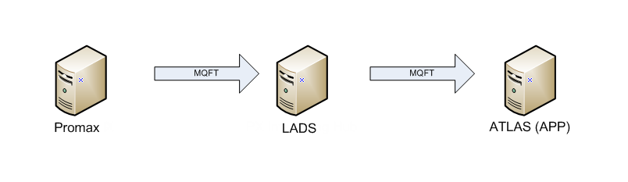

**Note:** Current interface is sent through LADS. No logic is applied, it is a standard passthru interface.

**Functional Overview (To-Be):**

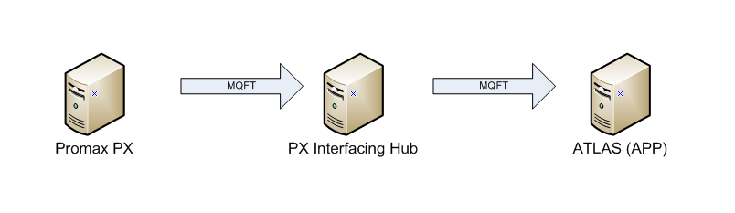

The following sections details what occurs at each of the systems in the above To-Be process.

# Interface Details

**Source Server:** WODNTS5 **Source Queue:** XPMXP01  
**Source Directory:** D:\apps\pmx\prod\outbound

**Destination Server:** WODLX008 **Destination Queue:** QM0217P  
**Destination Directory:** /ics/lad/prod/inbound  
**Destination Filename:** 331CLAIMS.txt

**Trigger Command:**

<file name="/ics/lad/prod/inbound/331CLAIMS.txt" label="PMXPXI02">  
 <job type="mqft_schedexit">  
 <command><![CDATA[/ics/lad/test/bin/ics_inbound_mqft.sh %f PMXPXI02]]></command>  
 <system>Simple</system>  
 </job>  
</file>

# Promax PX

Scripting details to be entered here.

# PX Interfacing Hub

The PX Interfacing Hub is the destination from the transfer from Promax PX.

When the file arrives to the PX Interfacing Hub it is configured to validate the data that has been sent, lookup the additional information that is required for loading AP Claims into ATLAS (APP), and then send the file onto ATLAS (APP).

As there are many steps within the PX Interfacing Hub, they have been split into subsections below:

## Validate the information from Promax PX

The file that is received from the PX interfacing Hub is loaded through a new interface that has been created for Promax PX data for NZ.

The following fields require validation:

* Spend Amount (Confirm it equals base +tax)
* Material
* Validate the amount field equals the tax amount field plus the base amount field.
* Validate the ‘Posting Key’ field from the file, if it is not equal to one of the following, then raise an error:
  + ‘Posting Key Payment Credit’
  + ‘Posting Key Reversal Credit’
  + ‘Posting Key Payment Debit’
  + ‘Posting Key Reversal Debit’

## Lookup additional information for interface to ATLAS

The next step is to lookup the additional information that is not provided by Promax PX.

The following reference information is looked up :

* Business Segment
* Material Determination for Traded Unit
* Profit Centre
* Plant Code

## Interface Logic.

The interface sends one customer

### Inbound

The following information is interfaced through to ATLAS (APP).

***To be confirmed with Craig and Steve which format we are using. examples of both below.***

***steve has requested the following format, overview***

* Ignore the header records (‘type’ field) from the file.
* Tax amount is checked to see if it is greater than zero. If it is then assign the S2 tax code. If not then assign the SE tax code.
* Check the ‘Posting Key’ field:
  + If it is equal to the ‘Posting Key Payment Credit’ or ‘Posting Key Reversal Credit’ value then do nothing. These records only apply to Header records which are ignored.
  + If it is equal to the ‘Posting Key Payment Debit’ value, then do nothing.
  + If it is equal to the ‘Posting Key Reversal Debit’ value, then negate the ‘amount’, ‘tax amount’ and ‘base amount’ fields to represent a payment reversal.
* Check the ‘Customer Is A Vendor’ field:
  + If it is equal to ‘V’ then this is an AP Claim or Vendor Payment:
    - The ‘item text’ field is made up of:
      * allocation field
      * reference field
      * payee code (Vendor code is this case) field
    - The ‘claim text field is made up of:
      * reference field
      * interface number callback (fflu_utils.get_interface_number)
      * allocation field
  + else it is an AR Claim or a customer credit:

***Craig has requested the following, dot points of key functions/logic***

if posting_key is equal to pc_posting_key_reversal_debit (50) then negate the following fields:

* amount
* tax_amount
* base_amount

### Outbound

The outbound logic is captured in the PXIATL01 interface Technical Spec as it has been consolidated with Accruals. The decision for this was that the documents are the same IDOC type when sending to ATLAS and to consolidate the duplicated logic.

# ATLAS (APP)

ATLAS (APP) is the destination from the transfer from PX Interfacing Hub.

The interface is loaded into ATLAS against message type ZACC_DOCUMENT, and then processed into ATLAS.

TODO: Document the tasks to process and looking up these values in SAP.